Team: C
Architecture Design:
For the design of Nudge’s architecture, we chose to create a Model-View-Controller. We chose this style because it was the easiest for us to understand, and therefore represent our application. It makes it the easiest implementation out of all the functions of the system, showing how there will be multiple distinct views and their relations with the controller and model.
Architecture Design Diagram: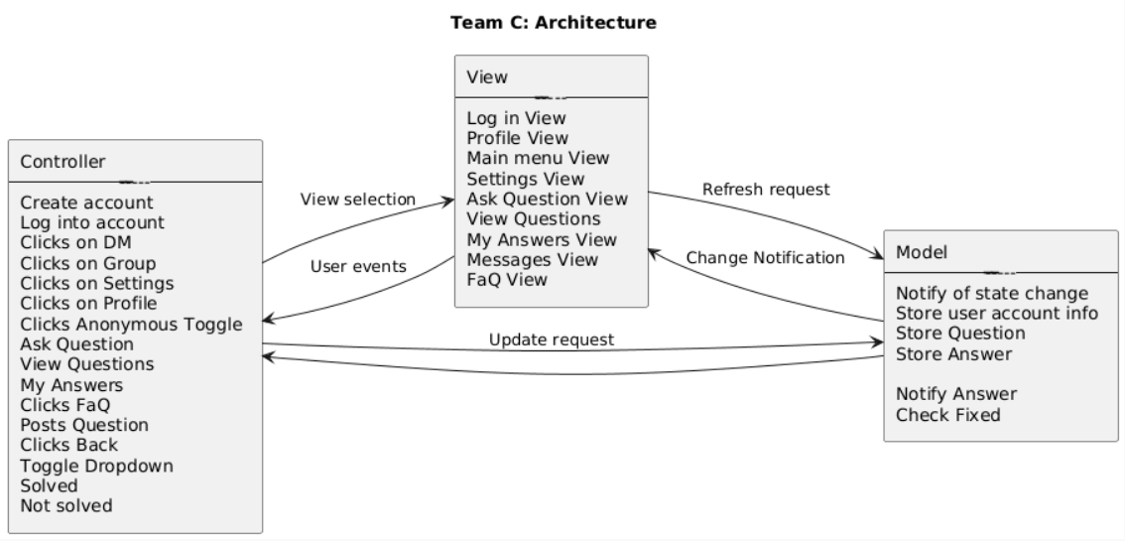
Design Description:
The architectural pattern consists of three components, the view, the controller and the model.
The view for Nudge handles the visual User interface of the web application. This is handled mostly by REACT and Bootstrap, also using Firebase as a means of logging into the application. The application has multiple views that can be displayed. When the user first opens the application, the view for logging in will be displayed, prompting the user to sign in. Any events that are interacted with will send information to the controller through the use of Buttons, TextElements, and HTML Elements.

The controller handles the events that are displayed to the user in the View. These events can be a button press to toggle views, submit entry into text boxes, and a toggle. When input is detected, the controller contacts the view if necessary and the model of any state changes.

The model for Nudge controls the data from the web app. Here the view can access the data that is taken by the interaction with the controller to accurately update the UI. Any changes to the state are stored in Firebase, and if necessary an update notification will be sent to the view controller. This allows the view to be updated and changed when a toggle is activated, or a user input is collected. The communication between the Database and the View controller is crucial to the function of updating the information in the UI of the application.

